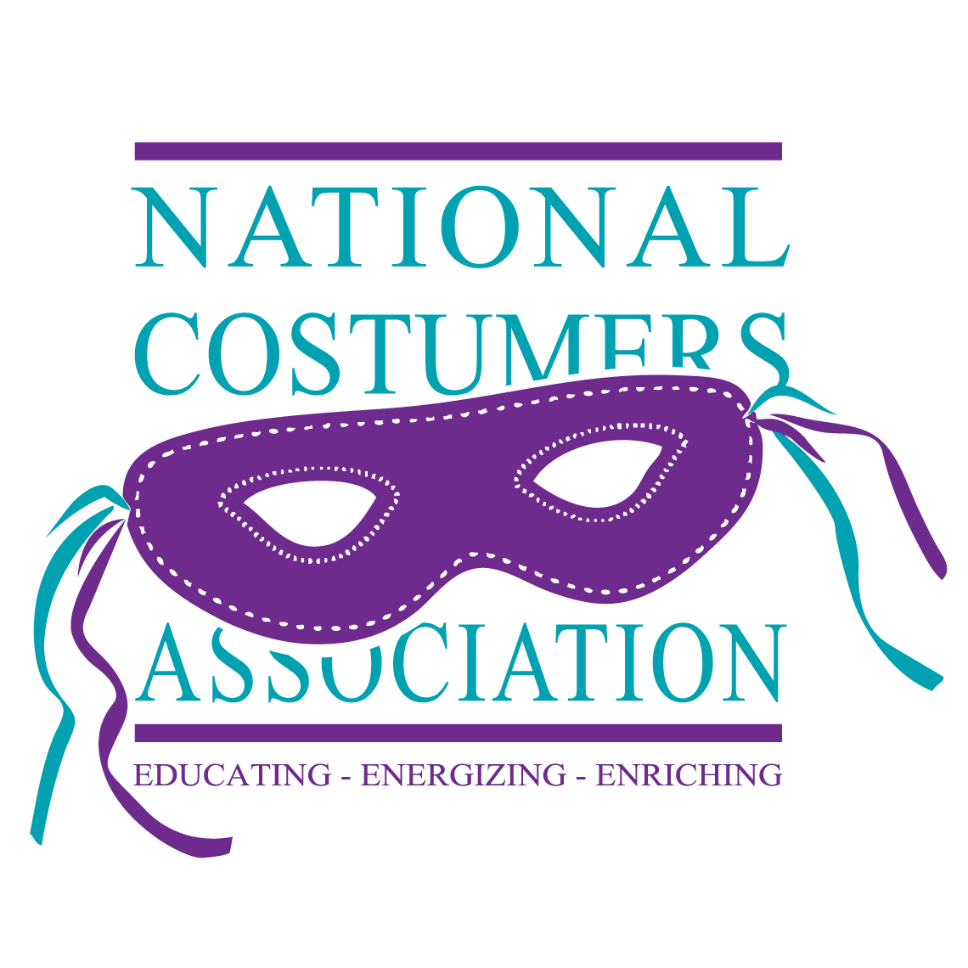
MEMORIAL FUND SCHOLARSHIP APPLICATION CRITERIA

The National Costumers Association promotes the costume industry through education. The NCA awards scholarships to qualified applicants. A “qualified” individual must be 17 years of age or older, maintain a GPA of 2.75 or higher, and be enrolled or enrolling in an accredited university or school. All applications must be submitted electronically by April 1 each year. Applications are accepted any time before the deadline.

The Memorial Fund Committee of the National Costumers Association shall award the scholarships during the annual meeting of the organization.

The actual dollar amount of any award will be determined by the amount of funds available and the number of qualified applicants. The Chairperson will notify recipients within two weeks of the meeting at which time the applicant has to accept or reject the scholarship. Upon receiving the completed and signed acceptance form, the National Costumers Association will disburse checks payable to the university or school designated on the application form.

Criteria for the scholarship program are:
1. A completed and signed application form submitted electronically.
2. Proof of GPA of 2.75 or higher (high school or university freshman is acceptable). Above average GPA is preferable.
3. Copy of online transcript.
4. Photo of applicant (headshot preferred).
5. A 100-word (max) biography.
6. A 500-word essay (minimum) of field of study and how it applies to the costume industry. Business courses may also qualify.

Questions may be directed to the Immediate Past President, Linda Adams Foat, at ipp@costumers.org.

